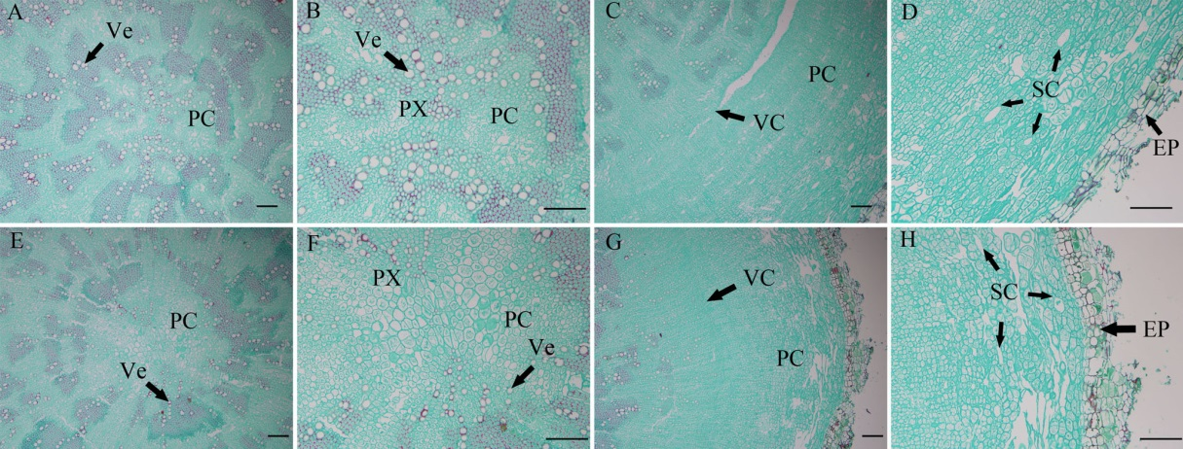
Fig. S1 Transverse sections of the roots of control and treated B. chinense DC. plants. a-d control plant, and e-h treated plant. Ve: vessel; PC: parenchyma; PX: primary xylem; SC: secretory canal; VC: vascular cambium; EP: epidermis. Bar=100μm.

